ECE 5470 Computer Vision Lab3 report

Segmentation Thresholding and Region Growing

Weiran Wang

NetID: ww463

# Peakiness Detection:

For the images mp, map, facsimile, shtl. I displayed histogram for each of them and tried several distance parameters and find the one gives the best image after thresholding.

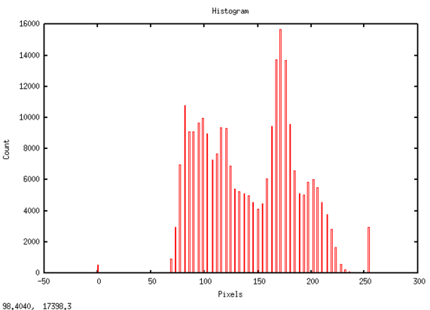 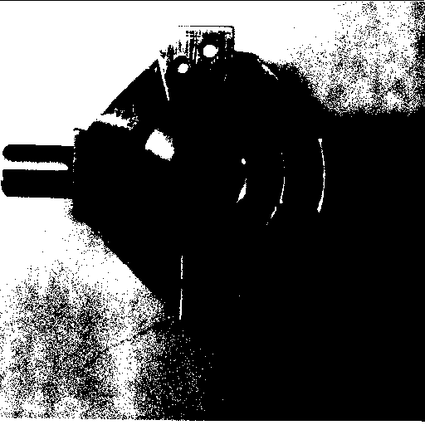

img1. Histogram of mp.vx img2. mp threshold:169

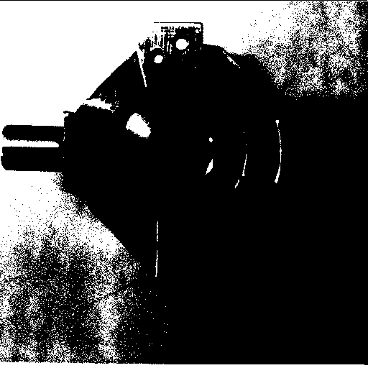 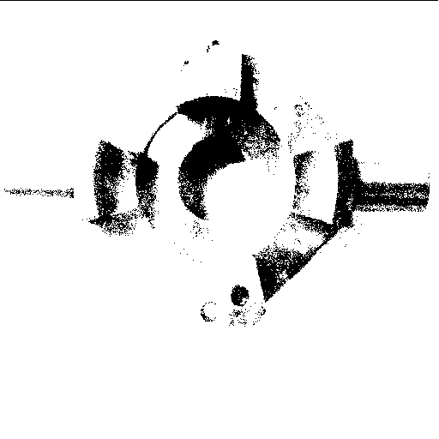

img3. mp threshold:173 img4. mp threshold:83

Facsimile:

As we can see from the histogram and results, threshold 231 has the best effect

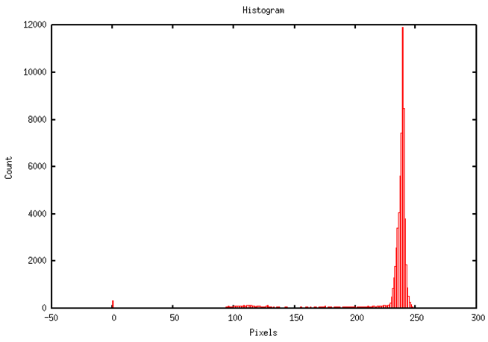 

img5. Histogram of facsimile img6. facsimile threshold: 241

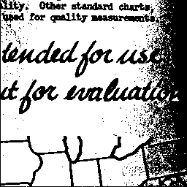 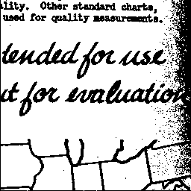 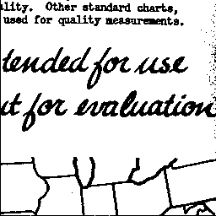

img7. facsimile threshold: 237 img8. facsimile threshold: 235 img9. facsimile threshold: 231

Map:

As we can see from the histogram and results, threshold 64 has the best effect

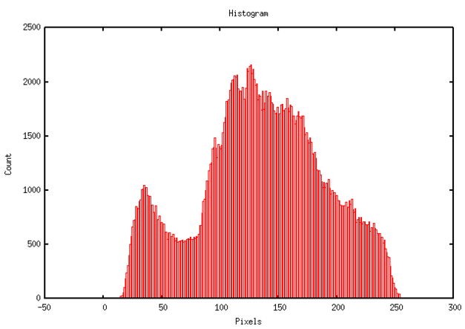 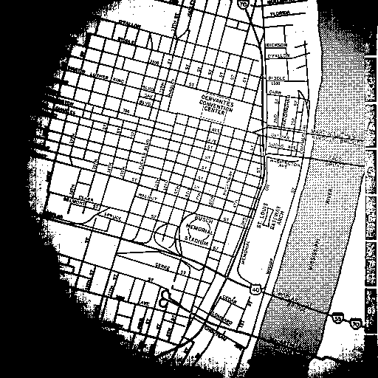

img10. Histogram of facsimile img11. map threshold: 126

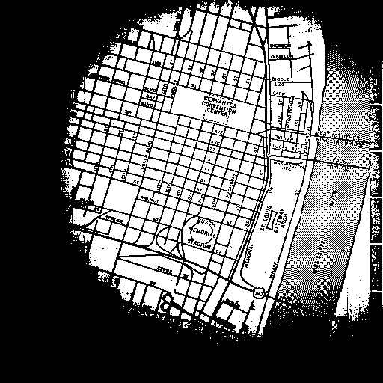 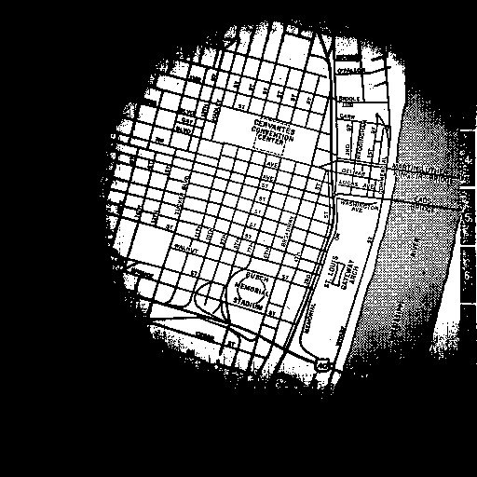

img12. map threshold: 148 img13. map threshold: 165

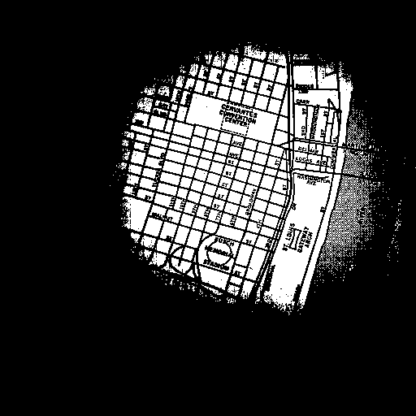 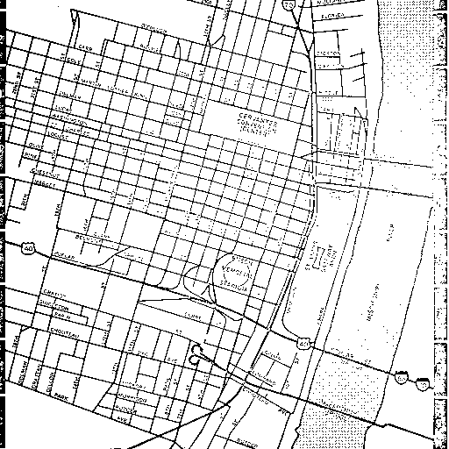

Img14. map threshold: 185 img15. map threshold: 64

Shtl:

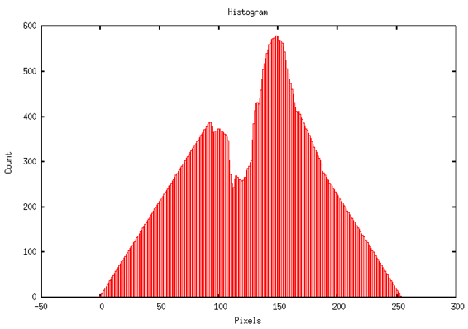 

Img16. Histogram of shtl img17.shtl threshold:148

  

Img18. shtl threshold:158 Img19.shtl threshold:167 Img20.shtl threshold:112

Analysis: From the results shown above, we can see the weakness is that peakiness algorithm is very sensitive of noise, especially when the noise creates peaks in the histogram, another weakness is when there are multiple peaks on the histogram, the performance of the algorithm is too dependent on the parameter such as maximum distance in this case. Of course, when the peaks are clear on the histogram, peakiness algorithm is caple of giving us almost the best result.

# Iterative Threshold(vits)

Description:

The images setup is the same as before, we have the new image im and old image tm. To find the threshold iteratively, I started by computing average pixel value of the whole image. Once I have the initial threshold, I partition the image to two parts. One part has all the pixels whose value are smaller than the threshold, the other has all the pixels whose value are greater than the threshold. In the program, I used sum1 and sum2 to keep track of the total pixel value for each region. Num1 and num2 are used to count number of pixels in for each region. After going through all pixels in the image, I computed average pixel value for these two regions by using sum1, sum2, num1, num2. The new threshold is calculated by threshold = (avg1 + avg2)/2. We can then use the new threshold to partition the image until avg1 and avg2 remain the same as the previous iteration. Otherwise, we keep partitioning and computing new threshold. When the iteration terminates, the threshold value is optimal.

Program:

#include "VisXV4.h" /* VisionX structure include file */

#include "Vutil.h" /* VisionX utility header files */

VXparam_t par[] = /* command line structure */

{

{ "if=", 0, " input file, vtpeak: threshold between hgram peaks"},

{ "of=", 0, " output file "},

{ "d=", 0, " min dist between hgram peaks (default 10)"},

{ "-v", 0, "(verbose) print threshold information"},

{ 0, 0, 0} /* list termination */

};

#define IVAL par[0].val

#define OVAL par[1].val

#define DVAL par[2].val

#define VFLAG par[3].val

main(argc, argv)

int argc;

char *argv[];

{

Vfstruct (im); /* input image structure */

int y,x; /* index counters */

int i;

int j;

int hist[256]; /* histogram bins */

int thresh; /* threshold */

int maxbin; /* maximum histogram bin */

int nxtbin; /* second maximum bin */

int minbin; /* minumim histogram bin */

int maxa, maxb; /* second maximum bin above/below maxbin */

int dist; /* minimum distance between maxima */

int cycle = 100000;

int sum = 0;

int sum1 = 0;

int sum2 = 0;

int num1 = 0;

int num2 = 0;

int avg1=0;

int avg2 = 0;

VXparse(&argc, &argv, par); /* parse the command line */

dist = 10; /* default dist */

if (DVAL) dist = atoi(DVAL); /* if d= was specified, get value */

if (dist < 0 || dist > 255) {

fprintf(stderr, "d= must be between 0 and 255\nUsing d=10\n");

dist = 10;

}

while ( Vfread( &im, IVAL) ) {

if ( im.type != VX_PBYTE ) {

fprintf (stderr, "error: image not byte type\n");

exit (1);

}

/* clear the histogram */

for (i = 0; i < 256; i++) hist[i] = 0;

/* compute the histogram */

for (y = im.ylo; y <= im.yhi; y++){

for (x = im.xlo; x <= im.xhi; x++){

hist[im.u[y][x]]++;

sum += im.u[y][x];

}

}

thresh = sum /(im.yhi*im.xhi);

/* compute the threshold */

for(i=1; i<cycle; i++){

sum1 = 0;

sum2 = 0;

num1 = 0;

num2 = 0;

for(j=0; j<thresh; j++){

sum1 += j*hist[j];

num1 += hist[j];

}

for(j=thresh; j<=255; j++){

sum2 += j*hist[j];

num2 += hist[j];

}

if(num1 == 0)

avg1 = 0;

else

avg1 = sum1/num1;

if(num2 == 0)

avg2 = 0;

else

avg2 = sum2/num2;

if(thresh == (avg1+avg2)/2)

break;

else

thresh == (avg1+avg2)/2;

}

/* apply the threshold */

for (y = im.ylo; y <= im.yhi; y++) {

for (x = im.xlo; x <= im.xhi; x++) {

if (im.u[y][x] >= thresh) im.u[y][x] = 255;

else im.u[y][x] = 0;

}

}

Vfwrite( &im, OVAL);

} /* end of every frame section */

exit(0);

}

Small images:

As we can see below, vits.c works for small images.

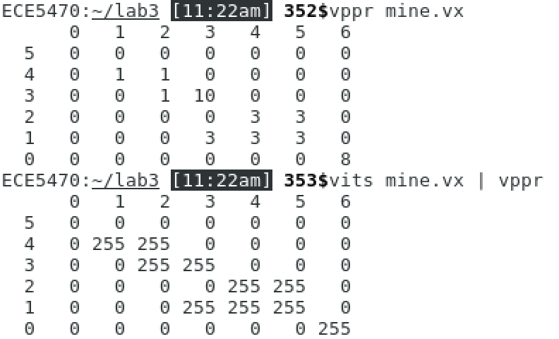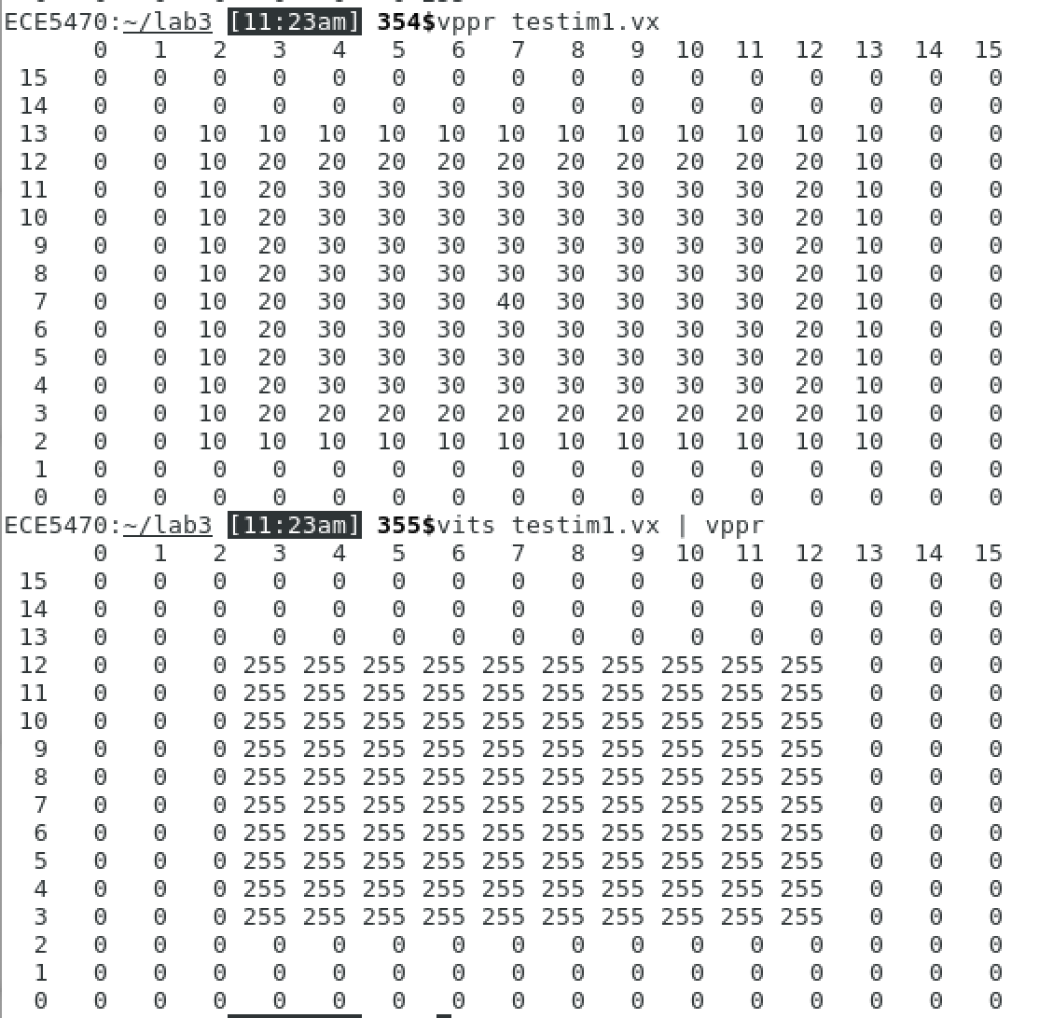

Img21. Small image results

Large images:

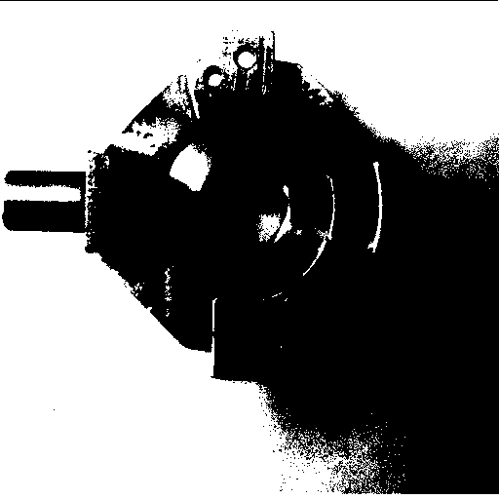 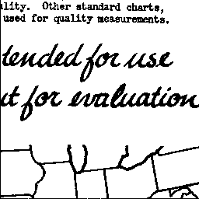

img22. mp iterative thresholding result img23.facsimile iterative thresholding result

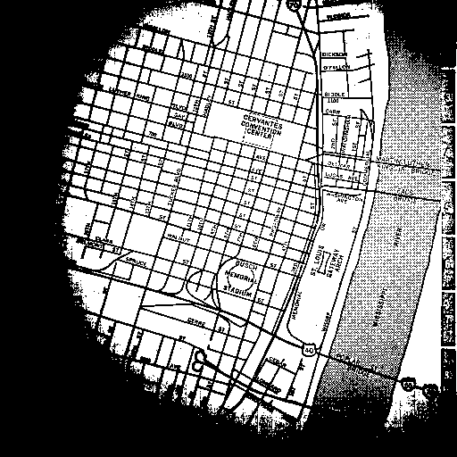 

img24. map iterative thresholding result img25. shtl iterative thresholding result

For large images, iterative algorithm works really good on img23 and img24. For image 25, the effect will be better if the algorithm gives a lower threshold.

# Adaptive Thresholding

After running patchval script with 9 different configuration, I observed the image sequence from mpa and mp and choose two best thresholding images from each of them.

map.seq:

img 26 has clearer boundary on the map whereas img27 contains more details

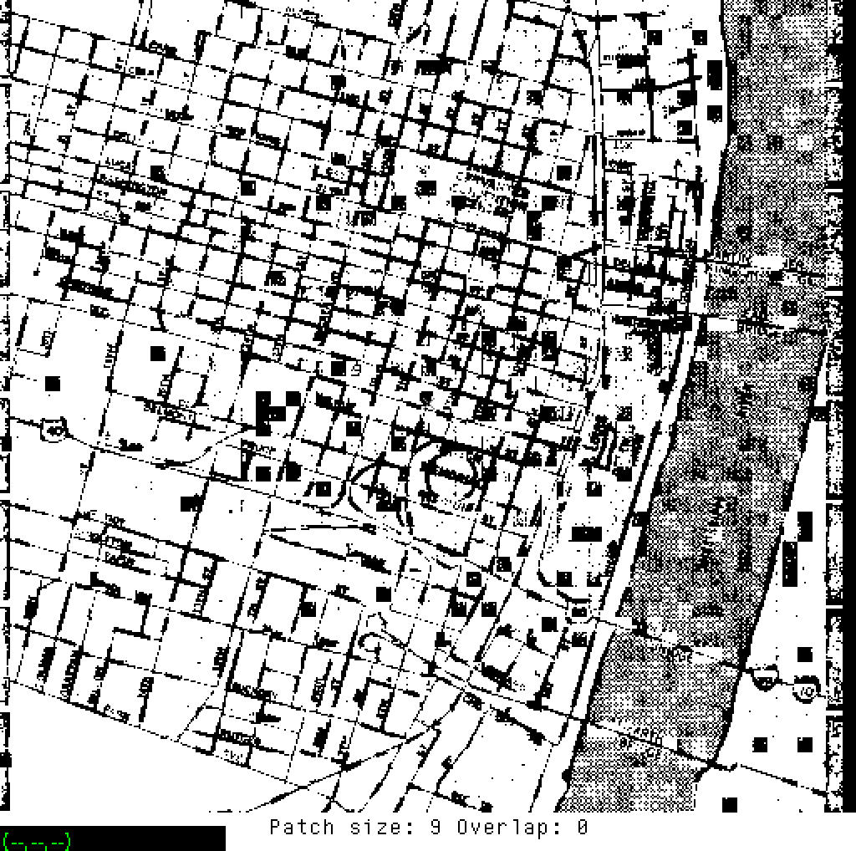 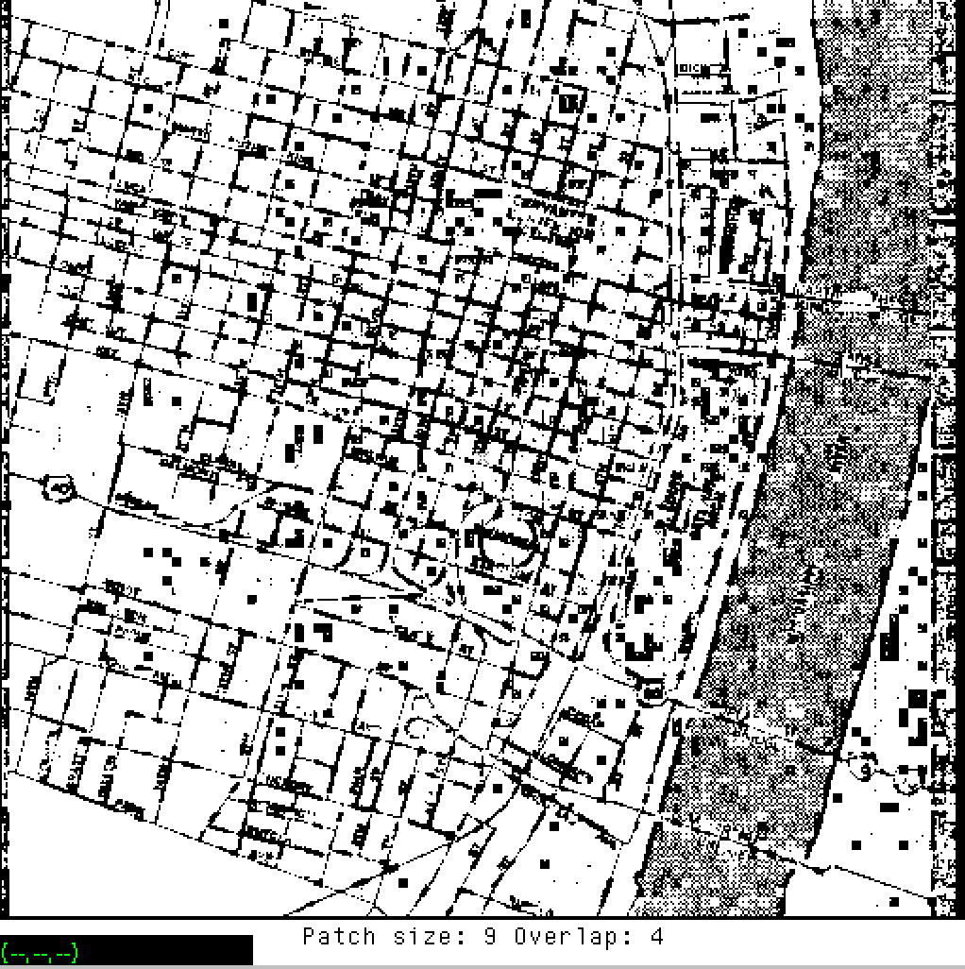

img26. Patch:9 Overlap:0 Img27. Patch:9 Overlap:0

mp.vx.seq:

img 28 has more details and img 29 has more clearer general view of the image

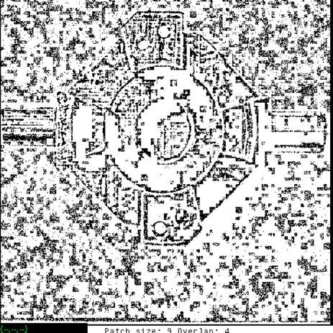 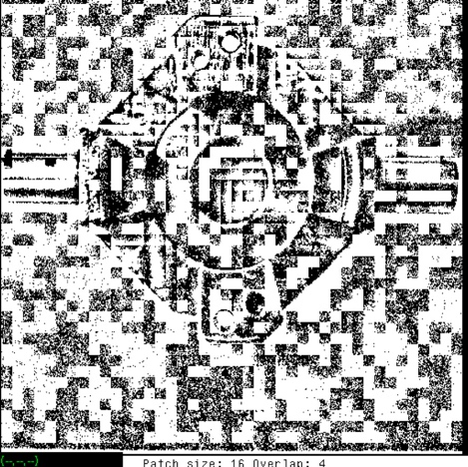

Img28. Patch:9 Overlap:4 Img29. Patch:16 Overlap:4

# Region Growing

Description:

Program vgrow.c has new parameters -p and r as required. -p is a flag that controls labeling scheme. When this flag is set, the label value will be the value of the first pixel in the region. Otherwise the regions are numbered sequentially. r is the maximum range within a region, if the pixel value difference is greater than r, we are going to label a new region. Based on program cclabel.c, region growing can also be achieved by recursion. For each pixel, we are going to recursively call the function setlabel to label four connected pixels(up down left right). If the original pixel value is not 0, and it hasn’t not been labeled, setlabel function is going to assign a label to the current pixel and recursively label connected pixels until the whole region is complete.

Program:

#include "VisXV4.h" /* VisionX structure include file */

#include "Vutil.h" /* VisionX utility header files */

VXparam_t par[] = /* command line structure */

{ /* prefix, value, description */

{ "if=", 0, " input file vtemp: local max filter "},

{ "of=", 0, " output file "},

{ "r=", 0, " region pixel range "},

{ "-p", 0, " set first pixel value in the region as label value "},

{ 0, 0, 0} /* list termination */

};

#define IVAL par[0].val

#define OVAL par[1].val

#define RANGE par[2].val

#define FLAG par[3].val

void setlabel(int, int, int);

Vfstruct (im); /* i/o image structure */

Vfstruct (tm); /* temp image structure */

int first;

int range;

main(argc, argv)

int argc;

char *argv[];

{

int y,x; /* index counters */

int label = 1;

VXparse(&argc, &argv, par); /* parse the command line */

range = 8; /* default range */

if (RANGE) range = atoi(RANGE); /* assign input value to range */

Vfread(&im, IVAL); /* read image file */

Vfembed(&tm, &im, 1,1,1,1); /* image structure with border */

if ( im.type != VX_PBYTE ) { /* check image format */

fprintf(stderr, "vtemp: no byte image data in input file\n");

exit(-1);

}

for (y = im.ylo ; y <= im.yhi ; y++) {

for (x = im.xlo; x <= im.xhi; x++) {

im.u[y][x] = 0;

}

}

for (y = im.ylo ; y<= im.yhi ; y++) {

for (x = im.xlo ; x <= im.xhi ; x++) {

if (tm.u[y][x] != 0 && im.u[y][x] == 0) {

first = tm.u[y][x];

if (FLAG) setlabel(x, y, first);

else {

setlabel(x, y, label);

if (label == 255) label = 1;

else label++;

}

}

}

}

Vfwrite(&im, OVAL); /* write image file */

exit(0);

}

/* function to compute the local maximum */

void setlabel(int x, int y, int label)

{

im.u[y][x] = label;

if (tm.u[y][x+1] != 0 && im.u[y][x+1] == 0 && abs(tm.u[y][x+1] - first) < range)

setlabel(x+1, y, label);

if (tm.u[y][x-1] != 0 && im.u[y][x-1] == 0 && abs(tm.u[y][x-1] - first) < range)

setlabel(x-1, y, label);

if (tm.u[y+1][x] != 0 && im.u[y+1][x] == 0 && abs(tm.u[y+1][x] - first) < range)

setlabel(x, y+1, label);

if (tm.u[y-1][x] != 0 && im.u[y-1][x] == 0 && abs(tm.u[y-1][x] - first) < range)

setlabel(x, y-1, label);

}

Small images:

As we can see vgrow.c works for small images with different parameters setup

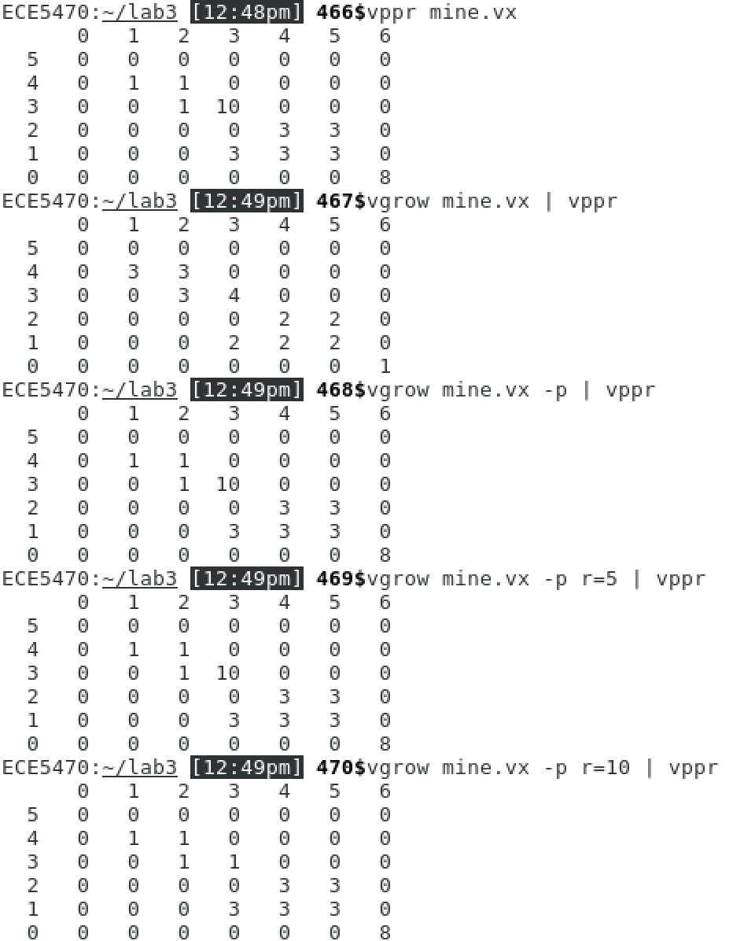 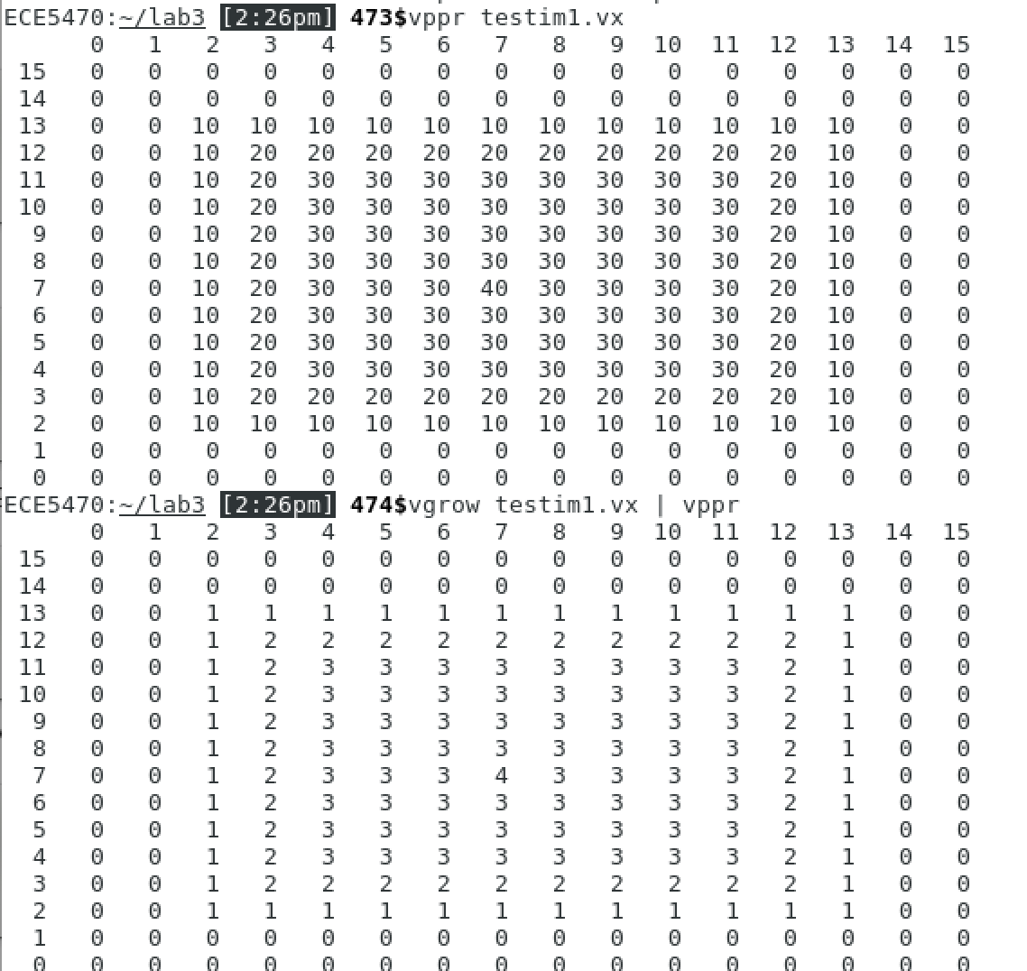

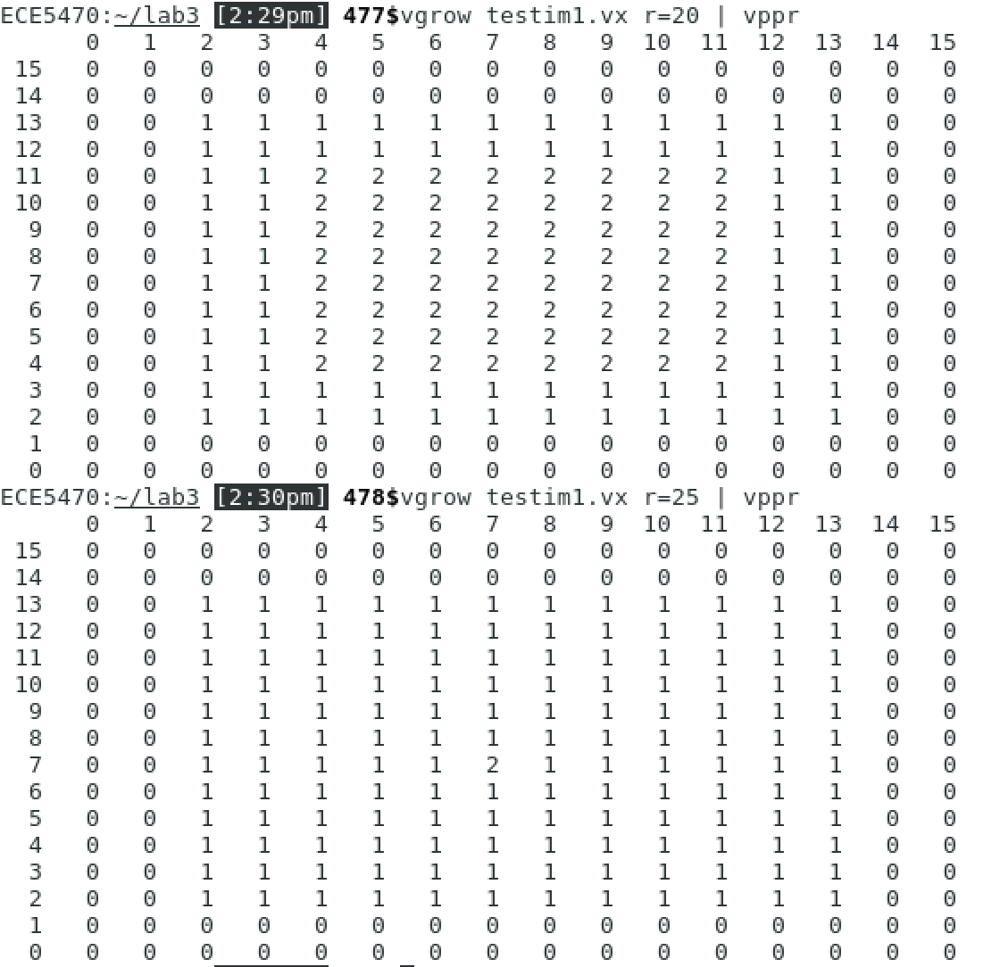 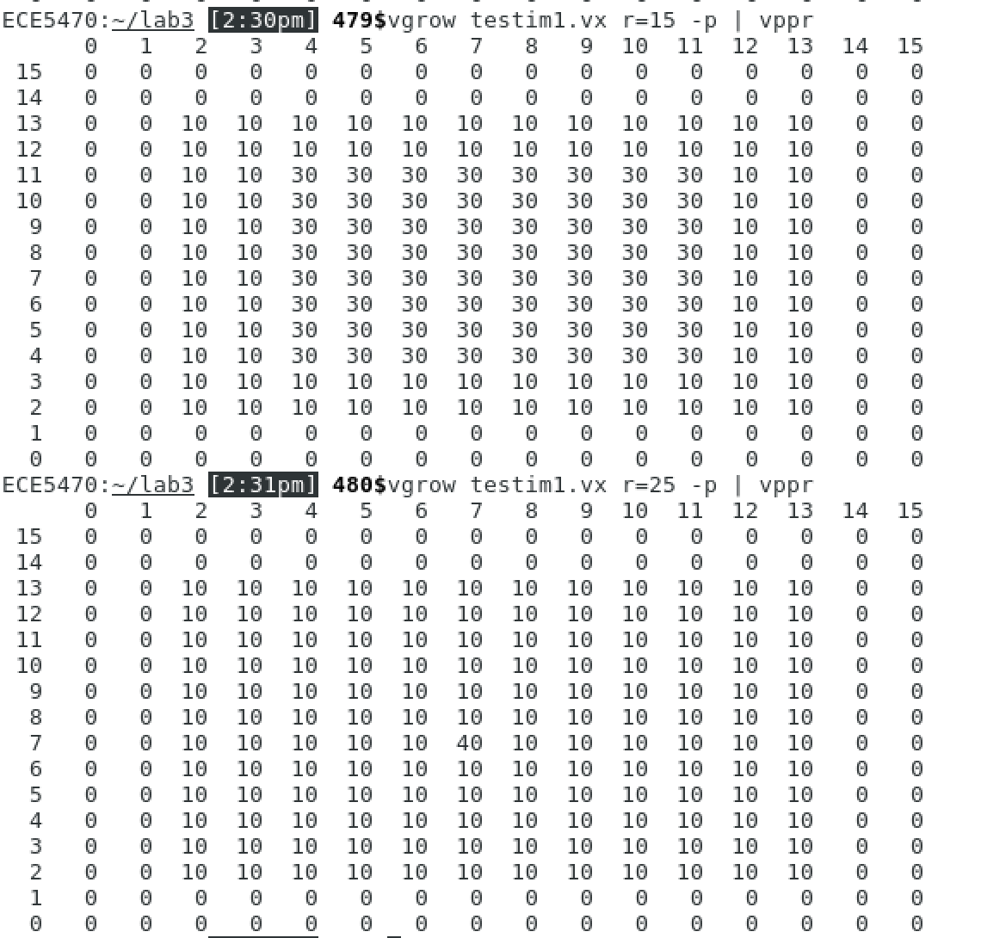

Img30. Small images region growing results

Large images:

As we can see from the images, the results are really blurry when the flag is not set. It would make a lot of sense to label the region with the first pixel value, because these are real-life objects images. Labeling the region sequentially would cause confusion. When the range is too large, objects in the image has a ‘fading’ effect. Generally, when flag p is set and range=5 nb.vx has better effect.

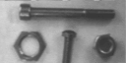 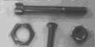

img31. Region growing -p, r=5 img32. Region growing -p, r=10

 

img33. Region growing r=5 img34. Region growing r=10

As we can see from the images, when range=5 edge.vx has better effect

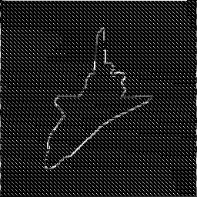 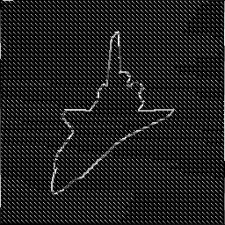 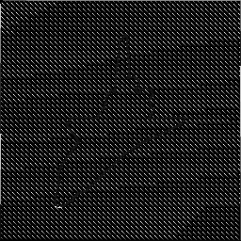

img35.Range = 2 img36.range = 5 img37.range = 10